Schneider M580 Sorting Line – FDS
Confidential
Erik van der Wal

Table of contents

Abbreviations 4
General 5
Applications 5
EcoStruxure Control Expert Classic (Control Expert XL + M580 Safety - V16.0) 5
SoMove 5
EcoStruxure Automation Device Maintenance 5
Common Platform Issues 6
Virtual Machine 9
Setup – Serial 9
Setup – Ethernet NAT 13
Setup – USB-C Ethernet (Bridged) 14
Programming 15
PC PLC 15
PLC PC 17
Hardware 18
Importing ESD File 18
Updating DTM Catalog 21
Communication Module 23
Communication Network 25
Drive 26
Pre-requisites 26
Local Network Settings 27
Connection 28
Add In Project (Fixed IP) 29
Add In Project (DHCP by PLC) 32
Fieldbus Discovery 33
Setup 34
Parameters 35
Load configuration 37
FDR 40
M/S Mode 41
CIP 42
Firmware 47
Pre-requisites 47
Adding Device 48
Connecting to device 51
Preparing firmware 52
Updating firmware 53
Recovery device 56
OPC-UA 57
Server - Advanced 57
Server - Standard 62
Client (Testing) 64
RIO or LIO 66
Pre-requisites 66
Adding Location (LIO or RIO) 66
TeSys Island 73
Pre-requisites 73
Project configuration (Control Expert) 74
Adding Location (Motor group) 74
Name 77
Main Island Configuration 78
Add Avatar (Motor) 78
Settings Avatar (Motor) 80
Copy and Paste - Device 82
Setting up Island (Online) 84

Abbreviations
This document uses several abbreviations, therefore the explanation for the abbreviations is listed below:
Term | Description
CM | Control module
EM | Equipment module
UN | Unit
PC | Process Cell
fb | Feedback
CS | Control Signal
HMI | Human-Machine Interface
STS | Status
ALM | Alarm
PAR | Parameter
FP | Faceplate
En | Enable
WRN | Warning
Dly | Delay
Ti | Timer
INT | Integer
UDT | User Defined Type
AI | Analogue input
AO | Analogue output
LL | Low Low
L | Low
HH | High High
H | High
DOL | Direct Online
UI | User Interface
Repository | Often a name for a remote map, containing stored data
Baler | Bollegraaf machine, that can press materials into a bale
FIFO | First In, First Out Object that reports first, if the first to be handled
End-user | Can be an operator, or a Bollegraaf (service) engineer

External Links
Document/File | Version | Usage
M580 Programming - Guide | 02-05-2025 | Guide to program M580 platform and components

General
NOTE: Before setting up any Schneider – Order/Project, please read the M580 Programming Guide

Overall
The overall program structure is setup in a way, to accomplish the following key aspects:
- Ease of use (FB’s have pre-installed Global variable links)
- Clear flow of data (Hardware signals: Inputs (program) Process Outputs)
- Flexibility of different divers/motor objects (each object can be a Motor starter, a drive or a simple relay)
- Clear variable naming (naming of variables should be clear)
- All in depth code = Structured Text, only overview block are FB (only intended adjustable area’s are FB based)

Overview
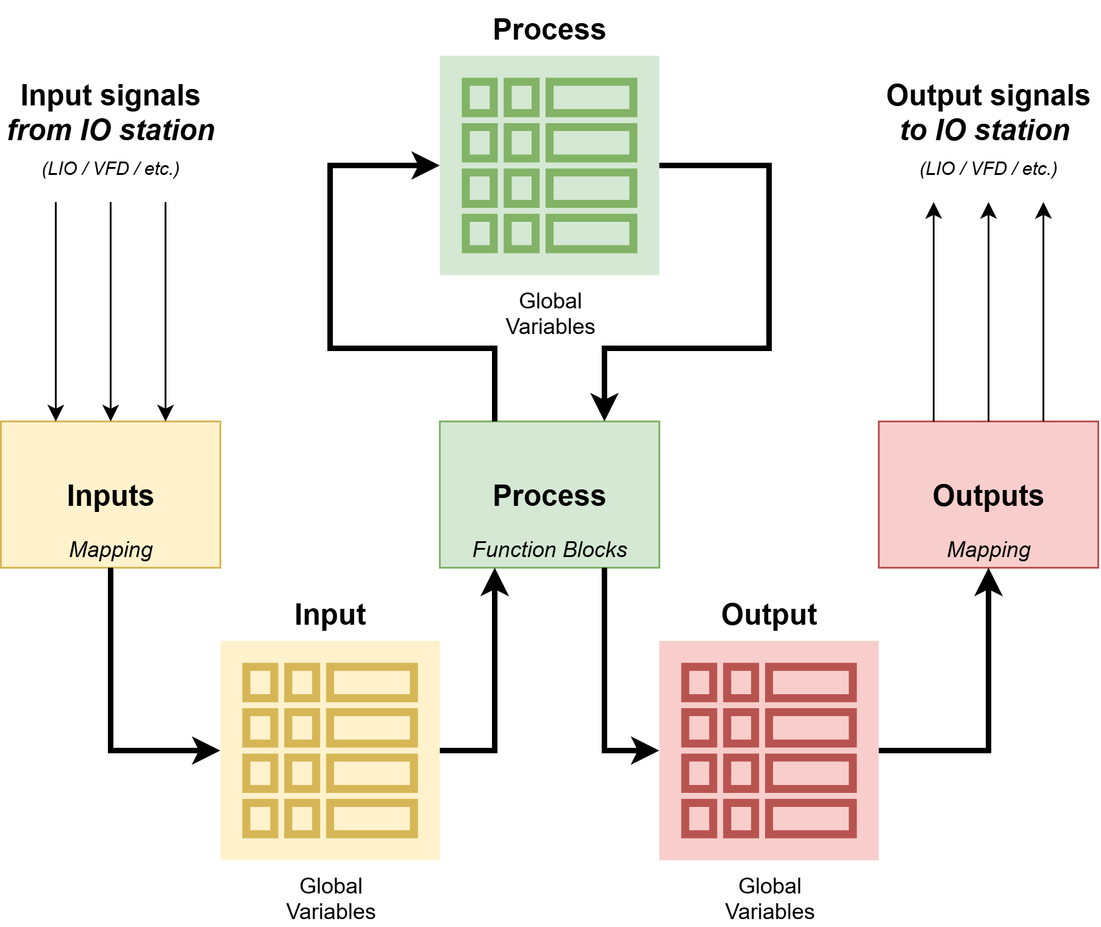
Most of the program blocks are written or interconnected in such a way, that the following structure can be applied to most of the Objects:
At the current software version, this structure is currently in place for most objects and features. The basic structure consists of 3 main processes (independently executable processes) , an Input process, a main Process and an Output process. These processes are linked through global variables to exchange data between each other.

Detailed
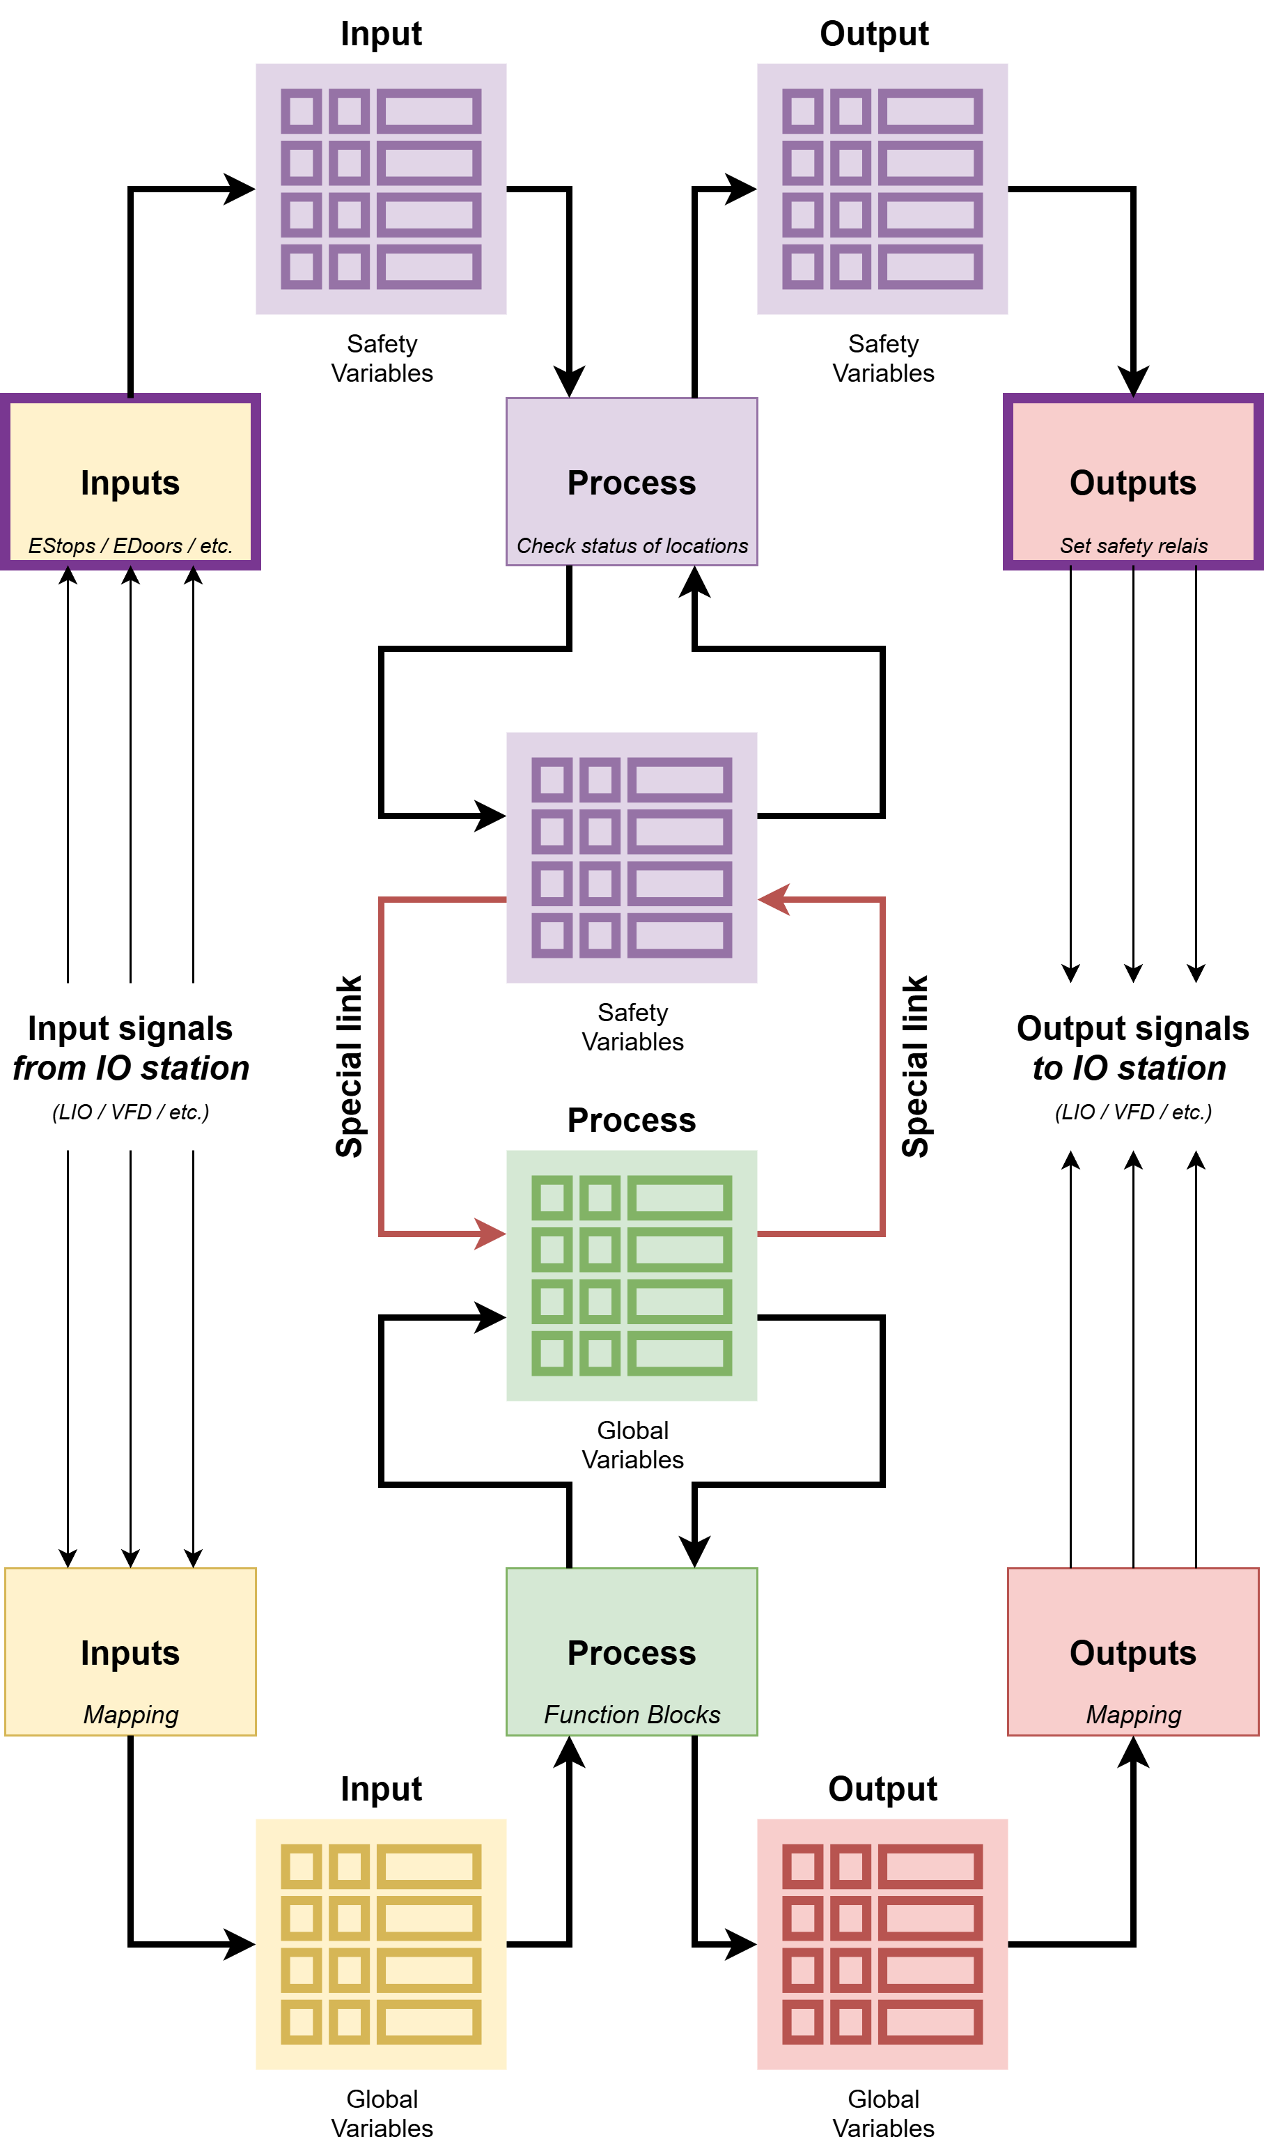
In the previous paragraph, an overview is provided of the program structure in a simplistic way. The figure below indicates the process structure with more details on very important data (like safety or others)

Processes

Functions

Object
An Object instance is basically a single Motor instance, but bridging the functional aspect between machine/system and the motor. The Object instance can be set as a conveyor, a motor of a screen, a chain hoist of a bunker, external system Optical Sorter, etc.

General

Limits
The Object has several limit functionalities in place to keep some crucial values in check. Limits are in place for;
Variable | Function / purpose | Lower limit (min.) | Upper limit (max.) | Advised value
SpeedRPM
JogRPM
PercentageRunning
FeedbackTimeStart
FeedbackTimeStop
FeedDelay
OFFDelay

Factory Reset

Interface
Object can be interfaced with by several means, to keep the object flexible to fur fill many roles.

Manual

Auto

Pause

Feed

Motor (Driver)

Offline

Alarms

Settings

Motor

General

Control (Forward Reverse

Driver – VFD

Driver – Tesys

Driver – DOL

Statistics

Alarms

Faction

Manual

Auto

Runtime

Statistics

Offline (Group)

Alarms

Settings

Storage

General

Description

Parameters

Configuration

Conveyor

Auto

Jog

Doors

Auto Forward

Auto Reverse

Retry

No Sensor

Group

Fill

Alarms

Settings

Line Manager

Storage Manager

MCC

Doors

Climate Control

Power Supply

Transformer

Indicator

Claxon & Beacon

Hour Counter

Alarms

Settings

HMI

Object

Storage

Block Indicator

Recipes

Emergency

